- Company Profile for A Stickling: Insurance Broker
www.csmint.co.za
- Business Background
CSM International (Pty) Ltd is an FSP that started off in 1992. Coen Stickling is the founder member of CSM International and came from Armscor after a 17-year period as Senior Programmer System Engineer. Was Instrumental in the development of the Rooikat Armored car, from the first concept until production in 1990. Still one of the top developments in the world, received two Chief of the army appraisals on this project, worked on G6, Velskoen, Strelitzia and many other top-Secret Projects.
We currently have 20 Personnel and Combined. We have over 75 years of experience. As an FSP we service the total spectrum of Insurance and believe in whole system whole life approach. We currently function as independent. FSP with Binder Agreements from various Underwriters.
We have over R50 bil of assets under cover. We run a complete facility from underwriting, claims, payments, refunds etc. We believe in a Total Service approach and have various JSE listed companies in our portfolio.
- Clientele: Businesses & Individuals
- Target Market : As per Clientele
- Short Term Insurance Products
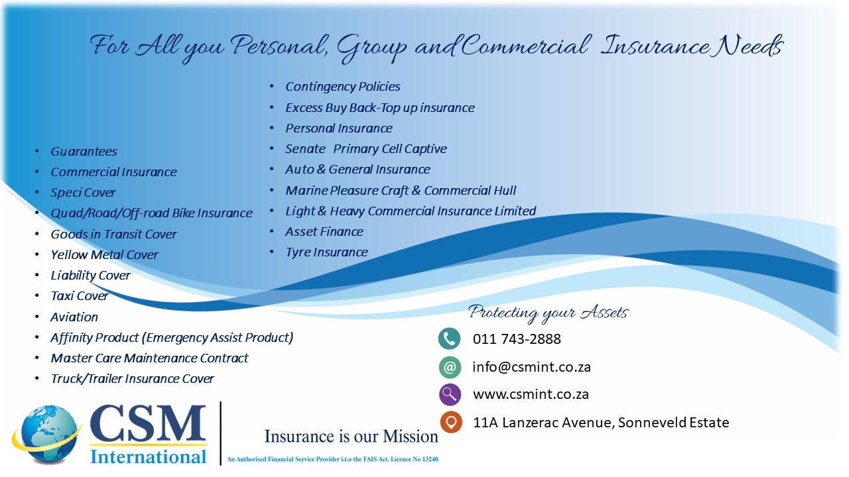

- Wealth Management – Long Term Insurance Products

- Underwriters and Insurance Company Products:
- Integritas Risk Solutions
- Hollard
- Western
- Yardrisk
- King Price
- Genric
- Senate
- Polygon Underwriting Agency
- Global Assist – Road Side Assist
- Excess Risk Consultants – Car hire & Motorvaps

